# 4 Simple Brainstorming Techniques That Will Help You Write Killer Content

#### By [Julie Neidlinger](http://coschedule.com/blog/author/julie/) on February 2, 2015



Brainstorming is supposed to be about harnessing the power of thinking outside the box to solve that impossible problem. It’s the magic that helps you find amazing, unique ideas.

It’s not magic, of course, but when you’re desperate—[possibly with writers block](http://coschedule.com/blog/writers-block/)—magic sounds good. Brainstorming techniques are what you turn to when you’re stuck and don’t know what to do next.

They can be great tools because anyone—group or single person—can use them.

## 4 Reasons You Should Brainstorm If You Want To Become a Better Writer

But why go through the hassle of using brainstorming techniques at all? There are generally four reasons that people turn to brainstorming:

1. You need ideas.
2. You have a problem to solve.
3. You are looking to improve creative thinking.
4. You want your team to work together better.

The first two reasons get the lion’s share of the attention, but the last two, which lean toward extra-curricular exercises, are just as important. If you want to be ready during go-time for the first two, you’d better take a few practice swings at it using the last two.

Whether it’s just you or you’re a part of a team, make brainstorming and creative challenges a regular habit.

### Brainstorming as a group.

First, a caveat. It’s no secret that I’m wary of [group brainstorming](http://coschedule.com/blog/brainstorming/). That particular method of getting ideas has become a standard solution for teams trying to solve problems.

While it can sometimes create more problems than it solves by encouraging social loafing and rewarding some personalities over others, there are times when your team has to get together and come up with ideas. Brainstorming techniques are also good for helping teams learn to work together.

**Brainstorming on your own.**

Brainstorming isn’t reserved for groups of people, though that’s how most of us think of it. There are times [when you’re on your own](http://coschedule.com/blog/get-high-traffic-blog-even-youre-blogging-solo/) and need to generate ideas and solve problems all the same.

As an artist and [writer with deadlines](http://coschedule.com/blog/how-to-write-faster/), I’m most familiar with brainstorming on my own. In fact, I did a little solo brainstorming recently, for this very topic.

While trying to come up with an idea for my own blog post, I realized that it might be helpful to readers if I told them how I came up with ideas and got past creative blocks in my own work—[14 ideas in all](http://loneprairie.net/brainstorming-techniques/).

As I looked through those 14 brainstorming techniques, I began to see three basic approaches to brainstorming that I thought would be useful to you.

[When you come to a roadblock, take a detour. —Mary Kay AshClick To Tweet](https://twitter.com/share?text=When+you+come+to+a+roadblock%2C+take+a+detour.+%E2%80%94Mary+Kay+Ash)

4 Brainstorming Techniques That Will Help You Write Creative Content

Brainstorming techniques can take a few basic approaches. Once you understand how they work, you can mix and match them for the best results.

### 1. Use associative brainstorming techniques to get unstuck.

Association is a powerful way to get past typical thinking, and to get out of a rut. We generally come up with [ideas that are obvious at first](http://coschedule.com/blog/familiarity/), and associative brainstorming is a good way to artificially force yourself past that point instead of hours of work.

It’s a kind of shortcut that taps into the subconscious, the associations you already know but don’t allow yourself to think.

Associative brainstorming works best for copy writers, creativity exercises, or when you’re stuck in a creative project and don’t know what content to create next.

This can also be fun during your regular team building exercises.

Word storm : A word storm is where you write down the words that come to mind when you see another word.

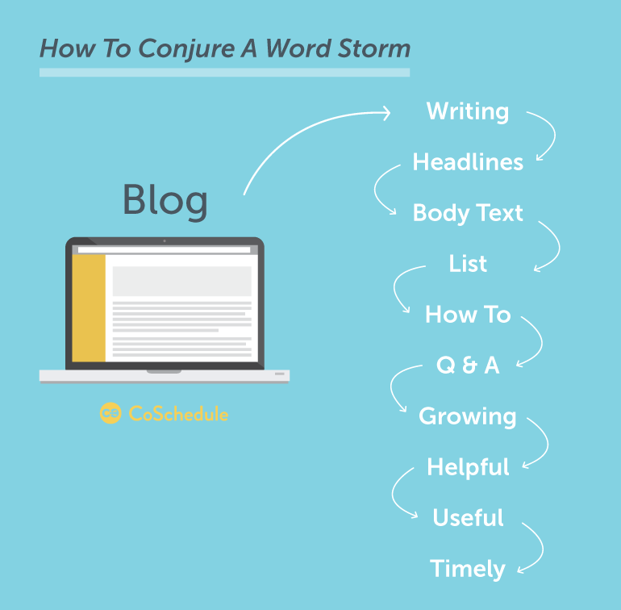

You might start with a word or two based on your project, and begin writing down any word that comes to mind. These words are then grouped together according to how they are related to each other.

You’ll quickly create words that are associated or related, according to categories.

There is a [Word Storm website](http://www.lonij.net/wordstorm/wordstorm.php) that can help you get started with word storm techniques.

#### Word association.

Word associations are the same as a word storm, except that you don’t group according to how the words are related to each other. It works better as a technique to get creativity flowing when you don’t want to bother with over-thinking how words are related.

Start with a word or two, and write down the first words that come to mind. Don’t over-think the process; you should be surprised at the words that pop into your head, particularly as you get warmed up.

The goal is to find those “hidden” words that people associate with a topic that you don’t immediately think of.

#### Mind mapping.

Using a mind map is a way to visually organize data and information. [Mind mapping](http://www.mindmapping.com/) has proven popular, particularly if you are better able to understand data visually instead of as lists or outlines.

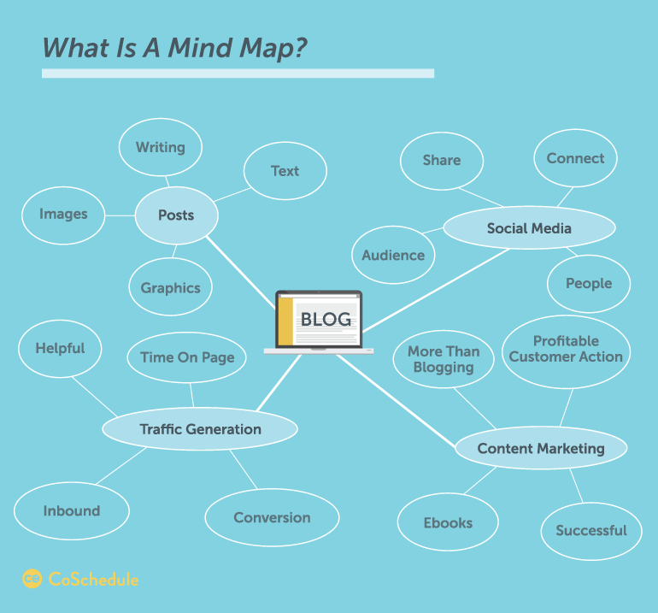

Organized around a central idea, a mind map works like the branch of a tree. Ideas and then sub ideas that are associated with the main idea branch off from the central idea.

#### Word banks: Word banks are collections of words based on the kind of word you need based on a specific topic or theme.

This kind of brainstorming technique works well for copywriters who want to find a variety of words that suit a specific project without repeating themselves. You can also use it to build a bank of words to keep on hand when [writing your headlines](http://coschedule.com/blog/emotional-headlines/).

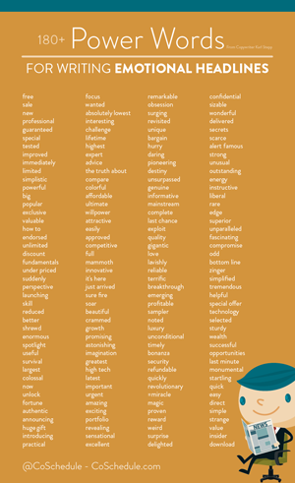

This is an example of power words we pulled together in a word bank to help you write more emotional headlines.

## Download This Word Bank Of 180+ Power Words For Emotional Headlines

Top of Form

Download It Now Free

Bottom of Form



Using a word storm might be one way to start a collection of words for your word bank, though the two techniques are not the same.

#### Visual association.

While visual associations aren’t a typical tool for content marketers, they can be useful both in [planning beforehand](http://coschedule.com/blog/blog-planning/) as well as after visual content has been created.

Using visual association after a project is completed would make sure that what you’ve created doesn’t raise negative associations in your audience. It is best done by people who weren’t on the team so that their associations are honest and not tainted by being [too familiar with the project](http://coschedule.com/blog/familiarity/).

Visual association is much like word association.



Think of a Rorschach test, in which you jot down whatever words or thoughts come to mind when you see an image. The control for this method is what images you will use.

I actually have a book where I collect images from magazines and other sources. You might do the same, or use a different image source.

**2. Use measurable brainstorming to choose the best solution.**

In some situations, you need to make decisions that are based on more than random associations. This is where problem solving brainstorming steps in, when you need something concrete.

#### Pros and cons: You probably already use an on-the-fly method of pros and cons to make decisions in life. Writing down pros and cons in a structured manner with a few rules can make this a powerful tool.

Write down what you are trying to choose between. Then, list the pros and cons to tally up a total. The option with the most pros is the route to go. You have to be careful to not cheat, though, and purposefully stack the list the way you want it to go.

Let’s look at an example of cheating. Say that Jim, Todd, and Erica make up Team B. Cheating would look like this:

**Con:** Team A will be upset.

**Pro:** Jim will be happy.

**Pro:** Todd will be happy.

**Pro:** Erica will be happy.

**Three pros, one con, the pros have it!**

Pros and cons help you cut through the gray area where you either aren’t sure what to do, or don’t want to admit what you know you should do. When done right, the numbers are convincing.

#### Pros and cons (weighted).

There are times when some pros and cons outweigh others. In this case, you would need to weight the list because each item is not equally important. To do this, you’d need to start by listing your top goals, the things most important to you.

Instead of each list item being counted as one, the more important items in your list of goals would have a higher weight.

Pros and cons seem simple, but we have a tendency to cheat. Often, there is a decision we want to be the right one and we try to validate it by loading the pros and cons either way.

### 3. Take a new view to gain an entirely new perspective.

While associative brainstorming helps you find entirely new paths, and measurable brainstorming gives you confidence to make decisions, finding a new view works when you’re on the right track but just not able to nail it down.

It’s that feeling of being so close, but not quite there.

#### Ask, “What if…”

By simply asking, “What if?”, you can turn everything on its head.

Many fiction writers advocate asking yourself “what if” not only when you’re stuck, but even when the writing is going well. Wondering what might happen if something changed, and using your brainstorming prowess to run with it, is a good way to get a different view on the project or problem.

**Think prepositionally:** My 7th grade English teacher did me a great service when she helped us understand prepositional phrases by visualizing a box.

Prepositional phrases generally tell where something was, and so she said that any time you saw a phrase in a sentence that could be used in relation to a box, you probably were dealing with a prepositional phrase. For example: in the box, under the box, over the box, beside the box, and so on.



When it comes to brainstorming, it’s not about writing prepositional phrases, but it’s about imagining the problem or project you are working on to be like that box. What if you took a swing at it from the other side? From under it? From ahead of it?

Now you start challenging yourself to think of something from a different perspective, from a different time (past or present) and all sorts of directions.

#### Ask questions: Oddly, most of us, particularly when working in teams, have the answers we’re looking for (or close to it). We feel stuck, though, because we aren’t able to sift through all the questions and the rest of the creative noise and pare down to that answer we wanted.

By whittling away at what you know and removing the extraneous from the table, you can push aside the curtain and finally see the answer. This is where questions come into play.

Write down the questions you have about the project or problem. Then, for each of these questions, start listing the answers quickly.

As you begin to answer the initial questions, other questions will come to mind that are associated with the answers you’re jotting down. Write down these sub-questions and do the same procedure.

In a way, it’s like creating an outline that is based on questions.

### 4. Tweak your brainstorming techniques to get the best possible results.

The last brainstorming technique has a bit of a twist. It’s all about the different ways you can use brainstorming techniques to enhance what they do.

Each of the previous three brainstorming techniques can be made even more powerful by using a combination or integrating a few other methods to up the ante.

#### Power combinations: Look for combinations of techniques that work well together, or that your team seems to excel at.

For example, maybe doing word associations first and then morphing into word bank exercises is the best way to find words that work. Perhaps your designer finds great success in starting with visual associations and then using a mind map to organize those associations.

Find combinations that get the job done.

#### Idea switch: The idea switch can be used with just about any brainstorming technique in a team setting.

Start the brainstorming, but set a time limit. When the time is up, have your team members exchange what they were working on with another member, and continue brainstorming.

Each team member builds on what the other had started.

This is a good way to kick the rust out of each team member’s creativity, and force them to rethink the approach they had been working on.

It’s a kind of shortcut in that you might eventually end up there as a team. But forcing them to deal with the ideas of someone else and build on them will get you some interesting results much quicker.

#### Forced limitations:

As I mentioned in [my own brainstorming blog post](http://loneprairie.net/brainstorming-techniques/), forced limitations is a way to solve a difficult problem by creating a different problem.

With the idea that “necessity is the mother of invention”, forced limitations narrow the field of resources, options, time, or outcomes—and force the team to work with less. Often, having too many options is paralyzing, and forced limitations sparks creativity.

**Think of Apollo 13:**

They needed to get a square peg into a round hole in a limited time using limited materials in a way that could be recreated by the Apollo astronauts. And they did.

Imagine, though, if they had any materials they wanted, and all the time in the world. How many billions would it have taken, how many government contracts, how complicated would it have been, to get to the ultimate solution?

Sometimes the limitations are, as in Apollo 13, not at all arbitrary. They are real.

But sometimes you have no limitations and you need to create some arbitrary limitations to get the same effect. Maybe you’ll choose to reduce the time allowed for a solution, the materials available, or narrowly defined goal.

Whatever it is, you’ll see that creativity has a way of growing when there is less to work with. Forced limitations have a way of cutting to the chase, ridding the solution of the extraneous, and getting things done.

## 4 Reasons to Try Brainstorming Techniques

You’ve probably used many of these methods already in your life. But if you want to become a better writer, regular brainstorming will help you write more creative content.

I mentioned this earlier, but brainstorming:

1. Gives you new ideas.
2. Helps you work through problems.
3. Improves your creative thinking.
4. Helps your team work better together.

Give these brainstorming techniques a try, and see the difference they’ll provide the next time you create content.

# 25 Useful Brainstorming Techniques

Caught with a problem you cannot solve? Need new ideas and solutions? The process of brainstorming requires you to think out of the box that is keeping you in the problem.

The idea for this post was triggered by [a question from a reader](http://personalexcellence.co/blog/category/ask-celes/), who asked me on my thoughts of the best brainstorming methods to achieve the best results. Because brainstorming is applicable to all kinds of contexts and there is no one size fits all method, I thought it’ll be more helpful to write a post on the different possible types of brainstorming techniques we can use instead.

Here is a list of 25 brainstorming techniques you can use to get out of the situation you are in. From this list, you can assess what’s the best method for the issue you are facing and apply it accordingly.

1. **Time Travel.** How would you deal with this if you were in a different time period? 10 years ago? 100 years ago? 1,000 years ago? 10,000 years ago? How about in the future? 10 years later? 100 years later? 1,000 years later? 10,000 years later?
2. **Teleportation**: What if you were facing this problem in a different place? Different country? Different geographic region? Different universe? Different plane of existence? How would you handle it?
3. **Attribute change**. How would you think about this if you were a different gender? Age? Race? Intellect? Height? Weight? Nationality? Your Sanity? With each attribute change, you become exposed to a new spectrum of thinking you were subconsciously closed off from.
4. **Rolestorming.** What would you do if you were someone else? Your parent? Your teacher? Your manager? Your partner? Your best friend? Your enemy? Etc?
5. **Iconic Figures.** This is a spinoff of rolestorming. What if you were an iconic figure of the past? Buddha? Jesus? Krishna? Albert Einstein? Thomas Edison? Mother Theresa? Princess Diana? Winston Churchill? Adolf Hitler? How about the present? Barack Obama? [Steve Jobs](http://personalexcellence.co/blog/steve-jobs/)? Bill Gates? Warren Buffet? Steven Spielberg? Etc? How would you think about your situation?
6. **Superpowers**.This is another spinoff of rolestorming. What if you suddenly have superpowers? Superman? Spiderman? Wonderwoman? X-Men? The Hulk? One of the Fantastic Four? What would you do?
7. **Gap Filling.** Identify your current spot – Point A – and your end goal – Point B. What is the gap that exists between A and B? What are all the things you need to fill up this gap? List them down and find out what it takes to get them.
8. **Group Ideation.** Have a group brainstorming session! Get a group of people and start ideating together. More brains are better than one! Let the creative juices flow together!
9. **Mind Map.**Great tool to work out as many ideas as you can in hierarchical tree and cluster format. Start off with your goal in the center, branch out into the major sub-topics, continue to branch out into as many sub-sub-topics as needed. [Source Forge](http://freemind.sourceforge.net/" \t "_blank) is a great open-source mindmapping software that I use and highly recommend.
10. **Medici Effect.** [Medici Effect](http://www.themedicieffect.com/" \t "_blank) refers to how ideas in seemingly unrelated topics/fields intersect. Put your goal alongside similar goals in different areas/contexts and identify parallel themes/solutions. For example, if your goal is to be an award winning artist, look at award winning musicians, educators, game developers, computer makers, businessmen, etc. Are there any commonalities that lie among all of them that you can apply to your situation? What worked for each of them that you can adopt?
11. **SWOT Analysis.**Do a SWOT of your situation – What are the Strengths? Weaknesses? Opportunities? Threats? The analysis will open you up to ideas you may not be aware before.
12. **Brain Writing**. Get a group of people and have them write their ideas on their own sheet of paper. After 10 minutes, rotate the sheets to different people and build off what the others wrote on their paper. Continue until everyone has written on everyone else’s sheet.
13. **Trigger Method.**Brainstorm on as many ideas as possible. Then select the best ones and brainstorm on those ideas as ‘triggers’ for more ideas. Repeat until you find the best solution.
14. **Variable Brainstorming.**First, identify the variable in the end outcome you look to achieve. For example, if your goal is to achieve X visitors to your website, the variable is # of visitors. Second, list all the possibilities for that variable. Different variations of visitors are gender/age/race/nationality/occupation/interests/etc. Think about the question with each different variable. For example, for Genre: How can you get more females to your website? How can you get more males to your website? For age: How can you get more teenagers to your website? How can you get more adults to your website? And so on.
15. **Niche.**This is the next level of variable brainstorming method. From the variations of the variable you have listed, mix and match them in different ways and brainstorm against those niches. For example, using the example in #14, how can you get more male teenagers to your website? (Gender & Age) How can you get more American female adults to your website? (Nationality, Gender & Age)
16. **Challenger.**List all the assumptions in your situation and challenge them. For example, your goal is to brainstorm on a list of ideas for your romance novel which you want to get published. There are several assumptions you are operating in here. #1: Genre to write: Romance. Why must it be that romance? Can it be a different genre? Another assumption is for a novel. #2: Length of the story: Novel. Why must it be a novel? Can it be a short story? A series of books? #3: Medium: Book. Why must be it a book? Can it be an ebook? Mp3? Video? And so on.
17. **Escape Thinking.** This is a variation of Challenger method. Look at the assumptions behind the goal you are trying to achieve, then flip that assumption around and look at your goal from that new angle. For example, you want to earn more income from selling books. Your assumption may be ‘People buy books for themselves’. Flip the assumption around such that ‘People do NOT buy books for reading’. What will this lead to? You may end up with people buy books as gifts, for collection purposes, etc. Another assumption may be ‘People read books’. The flip side of this assumption may be people look at books (drawings). Escaping from these assumptions will bring you to a different realm of thought on how to achieve your goal.
18. **Reverse Thinking**. Think about what everyone will typically do in your situation. Then do the opposite.
19. **Counteraction Busting.**What counteracting forces are you facing in your scenario? For example, if you want to increase traffic to your website, two counteracting forces may be the number of ads you put and the pageviews of your site. The more ads you put, the more users will likely be annoyed and surf away. What can you do such that the counteraction no longer exists or the counteraction is no longer an issue? Some solutions may be 1) Get ads that are closely related to the theme of your site 2) Get contextual ads that are part of your content rather than separate, and so on.
20. **Resource Availability.** What if money, time, people, supplies are not issues at all? What if you can ask for whatever you want and have it happen? What will you do?
21. **Drivers Analysis.** What are the forces that help drive you forward in your situation? What are the forces that are acting against you? Think about how you can magnify the former and reduce/eliminate the latter.
22. **Exaggeration.** Exaggerate your goal and see how you will deal with it now. **Enlarge it:**What if it is 10 times its current size? 100 times? 1000 times? **Shrink it:** What if it is 1/10 its current size? 1/100? 1/1000? **Multiply it:** What if you have 10 of these goals now? 100? 1000?
23. **Get Random Input.** Get a random stimuli and try to see how you can fit it into your situation. Get a random word/image from a dictionary/webpage/book/magazine/newspaper/TV/etc, a random object from your room/house/workplace/neighborhood/etc and so on.
24. **[Meditation](http://personalexcellence.co/blog/how-to-meditate/)**. Focus on your key question such as ‘How can I solve XX problem?’ or ‘How can I achieve XX goal?’ and meditate on it in a quiet place. Have a pen and paper in front of you so you can write immediately whatever comes to mind. Do this for 30 minutes or as long as it takes.
25. **Write a list of 101 ideas.** Open your word processor and write a laundry list of at least 101 ideas to deal with your situation. Go wild and write whatever you can think of without restricting yourself. Do not stop until you have at least 101.

**Final note:** To get a quick mental boost in just 15 minutes, check out: [Increase Your Mental Clarity in Just 15 Minutes](http://personalexcellence.co/blog/brain-dumping/)

Get the manifesto version of this article: [[Manifesto] 25 Useful Brainstorming Techniques](http://personalexcellence.co/blog/brainstorming-manifesto/)

**10 Longtime Brainstorming Techniques that Still Work**

Don't be afraid to use an "oldie but goodie" when you've reached a roadblock on the path to solving a problem--it might just be your best solution.

There are hundreds of options for brainstorming--and [new ones arriving](http://www.inc.com/john-boitnott/5-weird-brainstorming-techniques-to-get-you-out-of-a-funk.html) all the time in our fast-paced digital world. However, for some a classic approach might be better than the latest app. It's all about finding what works best for you, taking into account learning styles, preferences, and any props you might have available. The next time you're [stumped about a decision](http://lifehacker.com/four-tricks-to-help-you-make-any-difficult-decision-987762341) or can't move forward, try out one of these traditional approaches. You might be surprised by how effective they (still) are.

1. **Teleporting Storming:** You're staring down a problem and can't seem to find the right approach. Imagine that you were in a different place or a different time. Would you approach it differently if you were dealing with it at your favorite vacation spot rather than your cubicle? What if this was 10 years ago and you had a penchant for taking a lot more risk? Imagine it from an alternate perspective and the path forward may become more clear.
2. **Figuring Storming:** Can you imagine how someone else might tackle an issue, whether it's a celebrity, your boss, or a role model? "I like to put myself in someone else's shoes and it often helps me see things from a fresh perspective," says [AdLift](http://adlift.com/" \t "_blank) CEO Prashant Puri. "I know quite a few people who do this and you really need to embrace role-playing to make it work. You have to really be them in order to benefit from their ideas."

3**. Mind the Gap:** Whether you realize it consciously or not, the actual problem you're struggling with is a gap. You know where you are (Point A) and where you want to get (Point Z), and it's that gap in between the two that needs to be filled. Write down all the steps necessary to get there so you have a tangible to-do list that's a lot easier to tackle.

1. **Changing Your Attributes:** You don't necessarily have to think of yourself as an entirely different person in order to see a fresh angle. What if there was just one attribute about you that was different--your race, gender, or [even weight can make a difference](http://www.mindbodygreen.com/0-12360/what-losing-100-pounds-taught-me-about-how-we-treat-overweight-people.html) in how you see a challenge. Every time you change an attribute, your subconscious cracks open a new door that might lead to your answer.
2. **Mind Mapping:** Perhaps the [most classic approach](http://en.wikipedia.org/wiki/Mind_map) of all, this is putting a goal in the center of a piece of paper or board, then branding into subtopics. Create as many subcategories as possible as well as ideas that spring from them. It's great for writers and other creative types who are looking for a commonality but have the freedom to get a little more innovative.
3. **Superstorming:** If you could have any superpower, how would that change your brainstorming session? Suddenly turning into Wolverine might make you look at a more blunt and aggressive approach. Having the X-ray vision of Superman could certainly help with transparency issues. Dabble in as many superpowers as possible to get the most diversity.
4. **Medici Effect Storming:** The Medici Effect describes how ideas might not be obviously related upon first examination. If you [seek out parallels](http://www.wired.com/2012/01/opposites-dont-attract-and-thats-bad-news/), however, you'll find many more commonalities than you thought. Maybe you have a goal of winning a specific prize--looking closer at other award winners (even if it's a different award) can help you pinpoint what they have in common and what you can embrace to up your odds.
5. **Blind Writing:** This can be used for just about any type of issue, not just writer's block. Forcing yourself to simply put pen to paper for a minimum of 10 minutes will open up new ideas. The only rule is you have to keep writing, even if it's to jot down, "I don't know what to write about." Eventually you'll come up with something. Whether or not it's a "winner" doesn't matter, because at least you're energizing the part of your mind that does the work of writing.
6. **Group Ideation Storming:** Two is better than one when it comes to brainstorming sessions. When you start [discussing ideas as a group](http://smallbusiness.chron.com/advantages-group-work-teamwork-24031.html), you'll naturally feed off of each other and discover more things. This can be especially helpful for brainstormers such as artists who often do their work solo.
7. **Reverse Storming:** This is an approach that attorneys love. Consider what most people would assume in your situation, and then figure out ways to do the opposite. One way is to [ask yourself](http://www.mindtools.com/pages/article/newCT_96.htm), "How could I stop this goal from happening." It's a way to look at new methods and approaches assuming it's your only option.

No matter what technique works for you, it's always beneficial to experiment. You might find that there are several techniques that help. Otherwise, who knows what you might be missing?